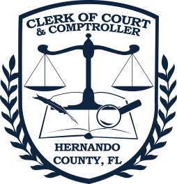Doug Chorvat, Jr. Clerk of Circuit Court & Comptroller - Hernando County   
20 N. Main Street, Brooksville, FL 34601 - (352) 754-4201

2025-2026 Operating Budget

Court Related Operations[1]

**Revenue**

Budget Authority from CCOC[2] $4,159,167.00

Juror State Revenue 166,000.00

Title IV-D Funds 180,000.00

Court Charges 952,294.00

Total $5,457,461.00

**Expenditures**

Personnel Services $4,476,687.00

Operating Expenses 28,480.00

State Collection for 67 Counties2  952,294.00

Total $5,457,461.00

County and other Non-Court Operations**[3]**

**Revenue**

BOCC Allocation $13,952,767.00

Charges for Services[4] 1,668,839.00

Total $15,621,606.00

**Expenditures**

Personnel Services $8,525,483.00

Operating Expenses 6,796,123.00

Capital Outlay 300,000.00

Total $15,621,606.00

1. In addition to the below budget the Clerk also receives revenues to offset technology costs from a portion of recording fees pursuant to Florida Statutes 28.24(12)(d) and 12(e).
2. The Clerk of Court Operations Corporation (CCOC) is the state entity which grants the budget authority for all 67 Clerks. Hernando County is one of only 19 counties in the State that collects more court revenue than it uses for operations.
3. On July 30, 2019 the Hernando County Commissioners voted to merge the Boards Technology Services Department with the Clerk of Hernando County Information Technology Department to streamline costs and improve workforce efficiencies.
4. The Clerk’s Office receives fees for a variety of services including the recording of land records, processing marriage licenses, performing ceremonies, and the initial processing steps for passports.